Sample Student Mini-Proposal Completed

Title: Patterns in the Average Summer Chlorophyll-a Concentration
Near Palmer Research Station, Antarctica from 2002-2014

Introduction
The topic area that we are interested in understanding more about is how summer chlorophyll levels have changed over time. To understand if summer chlorophyll levels are changing over time around Palmer Research Station, Antarctica we will use Palmer Long Term Ecological Research station data 2002-2014 (PAL-LTER, http://oceaninformatics.ucsd.edu/datazoo/data/pallter/datasets/). To make sure we have enough data to observe a long-term trend in summer chlorophyll we will compare fall averages across twelve years.

Testable Question & Hypothesis
Our testable question is: How did the amount of summer chlorophyll-a concentration vary from 2002-2014 near Palmer Research Station?
Our hypothesis is: the amount of summer chlorophyll has decreased over the twelve years.

Materials

PAL-LTER downloaded data, Excel, Internet access

Planned Procedure – Description of Data Collection
- Where were the data collected? – At selected depths at Palmer Station Antarctica, during PAL-LTER field seasons.
- Who collected the data? – PAL-LTER field technicians and scientists.
- How were the measurements taken? – Water samples were taken throughout the water column. Collected water was run through a fluorometer for fluorescence data to calculate the chlorophyll levels.
- Over what time period and how frequently were the data collected? – Water was collected 1-2 times per week from November-April in 1991-2015.
- What tools/methods were used to collect the data? – Bottle samples were used to collect the water. Fluorometer was used to process the water.
- What time period, of the full data set, will you use for your investigation? – December-February from 2002-2014.

Planned Procedure – Investigation Design Table
- Background Questions: How are chlorophyll-a calculations made from the fluorometer data? What factors influence how much chlorophyll-a is in the water?
- Independent Variable: Time (summer annual average)
- Dependent Variable: Chlorophyll-a concentration
- Constant(s): station, summer months, fluorometer protocol
- Control Group (if applicable): not applicable
- Treatment Group(s) (if applicable): not applicable

Planned Procedure – Description of Data Analysis
- What kind of data table will be used? – This is what the data table will look for the summer (December-February) annual comparisons. We will calculate the average summer amount of chlorophyll-a and the standard error (SE). We will note anything relevant about the data.
Year | Average Summer Chlorophyll-a | SE Summer Chlorophyll-a | Other Data Comments
2002
- How will the data be reviewed for outliers? – We will first plot all of the summer data before averaging it to see if there are any that are far outside the realm of possible and will remove them.
- What tools will be used to interpret the data? – To determine if there is a difference in the summer amount of chlorophyll-a over time, we will calculate and plot the average summer chlorophyll-a per year for twelve years, including error bars for SE. We will then visually compare the pattern (slope) of the overall amount of chlorophyll over time.
      - What type(s) of figure(s) will be used to show the data? – The average amount of summer chlorophyll-a will be plotted by year on a scatterplot.
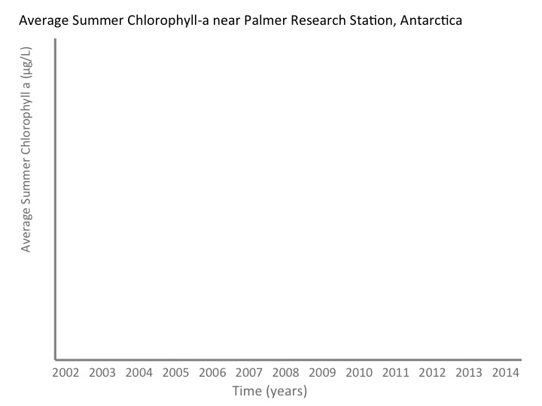
- What type(s) of math or statistics will be used to interpret the data? –
        - The average summer amount of chlorophyll-a will be calculated for each year by adding up data from December-February and then dividing by the total number of data points per year.
        - The standard error for chlorophyll-a from summer will be calculated for each year by dividing the average summer amount of chlorophyll-a by the square root of the total number of data points for that year. The standard error will be plotted as positive and negative error bars.

