Exploring Palmer LTER
http://pal.lternet.edu

I. Antarctica is a Continent: Look on a globe or at the map below. Name three things you notice and two things you wonder about it.

Notice:
- _________________________________________________________________________________________
- _________________________________________________________________________________________
- _________________________________________________________________________________________
Wonder:
- _________________________________________________________________________________________
- _________________________________________________________________________________________

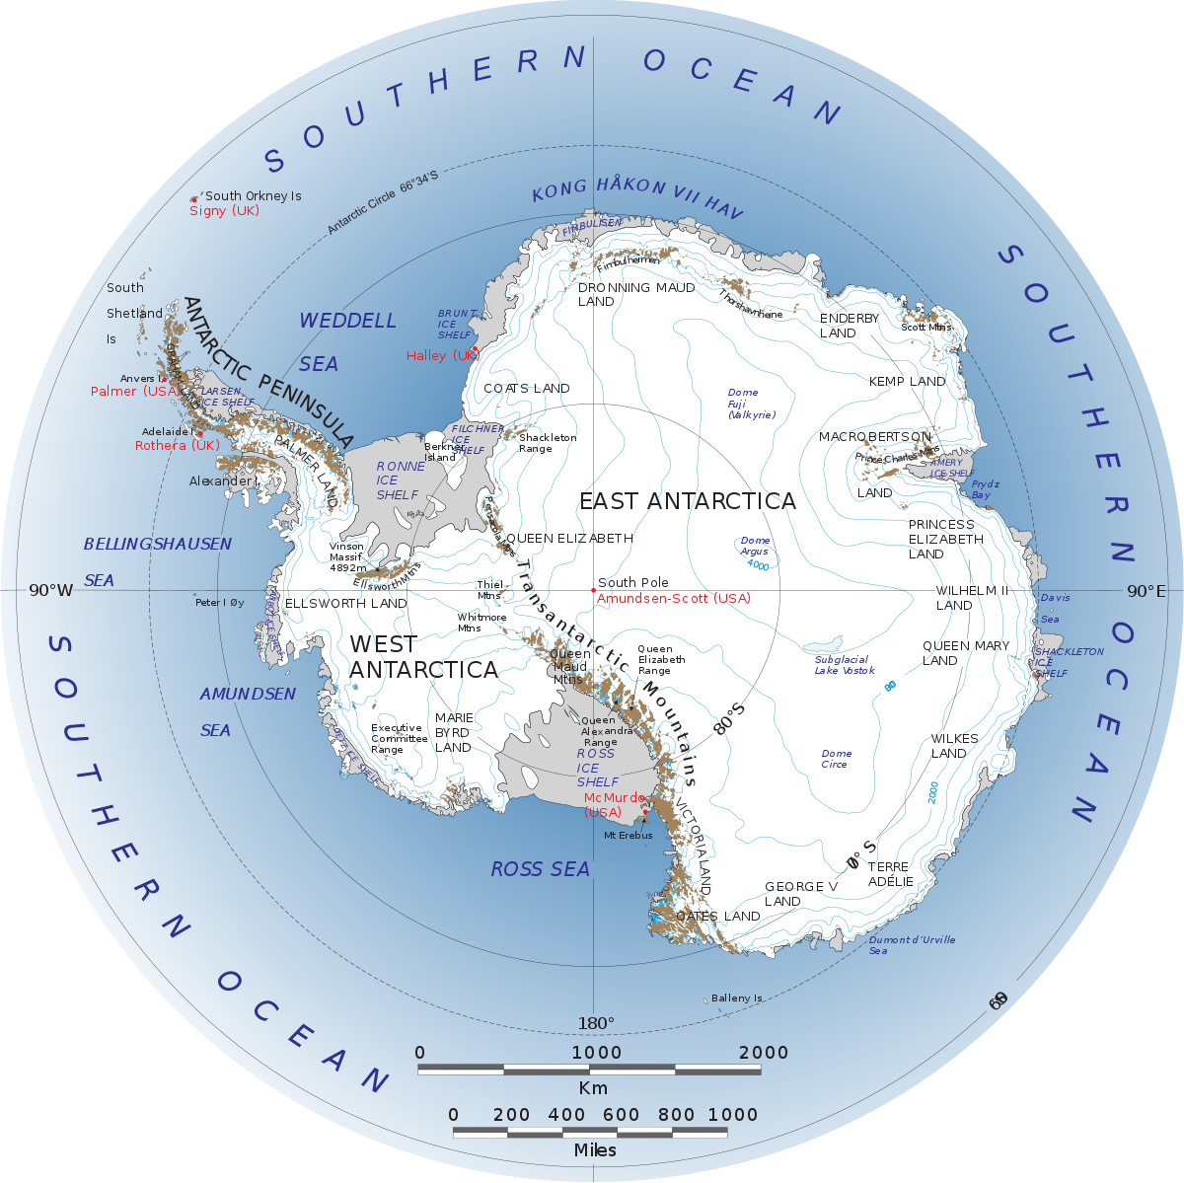

What do you know about the physical characteristics (weather, climate) of the Antarctic ecosystem? Write some of your ideas below:

__________________________________________________________________________________________________________________________________________________________________________________________________
__________________________________________________________________________________________________________________________________________________________________________________________________

What is the biological characteristics (organisms) that live in Antarctica? What do you know about how they interact with one another? Write some of your ideas below:
__________________________________________________________________________________________________________________________________________________________________________________________________
__________________________________________________________________________________________________________________________________________________________________________________________________

What organisms live in Antarctica? Write the name of the organism and one interesting fact about them on this diagram.
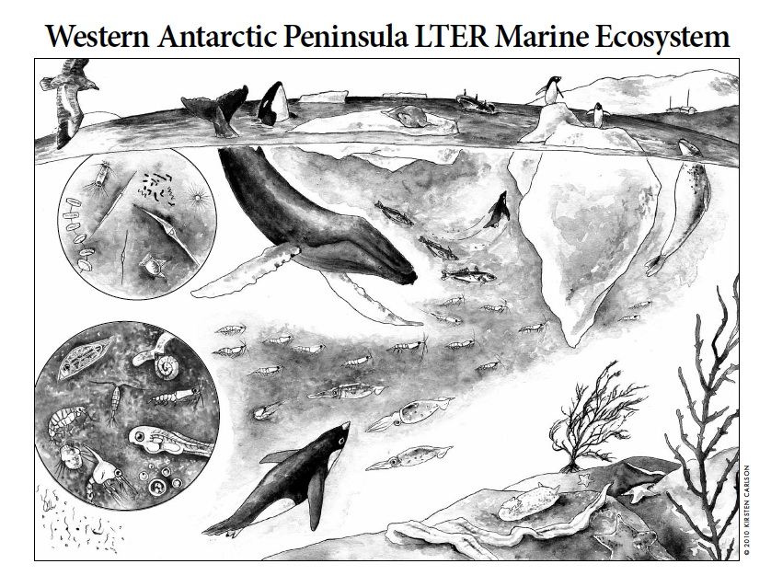
II. LTER Research: Scientists visit Antartica year-round to better understand this important ecosystem.

LTER is an Acronym. Write what each letter stands for below.

L:______________________________________________________________________________________________
T:______________________________________________________________________________________________
E:______________________________________________________________________________________________
R:______________________________________________________________________________________________

What do you think the value is of collecting scientific data over a long period of time in Antarctica?

__________________________________________________________________________________________________________________________________________________________________________________________________

Middle and high school students can read about each of the laboratories that work together to understand the Antarctic food web. http://pal.lternet.edu/research

What is most interesting to you? Why? Write some notes below:
__________________________________________________________________________________________________________________________________________________________________________________________________
__________________________________________________________________________________________________________________________________________________________________________________________________

III. Research Methods: Antartica is a cold and harsh environment. How do you think scientists study this important ecosystem? What equipment do they use?

__________________________________________________________________________________________________________________________________________________________________________________________________
__________________________________________________________________________________________________________________________________________________________________________________________________

Take a look at Palmer Station on the webcam: http://pal.lternet.edu/education/webcams

What do you notice about Palmer Station?
__________________________________________________________________________________________________________________________________________________________________________________________________
__________________________________________________________________________________________________________________________________________________________________________________________________

What questions do you have about Palmer Station?
__________________________________________________________________________________________________________________________________________________________________________________________________
__________________________________________________________________________________________________________________________________________________________________________________________________

IV. Organisms that Live on the Western Antartic Penisula

Penguins on the Western Antarctic Penisula

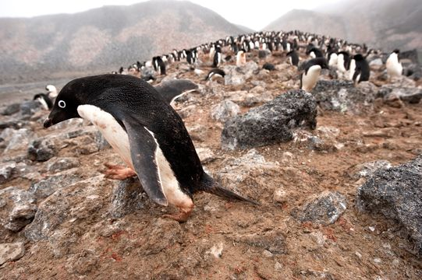 | 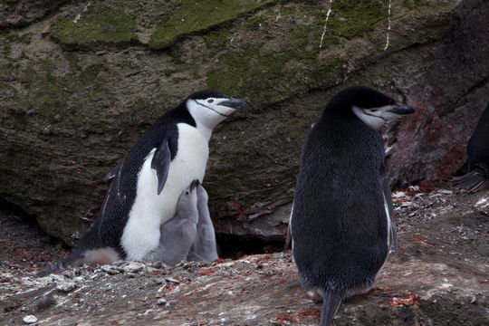 | 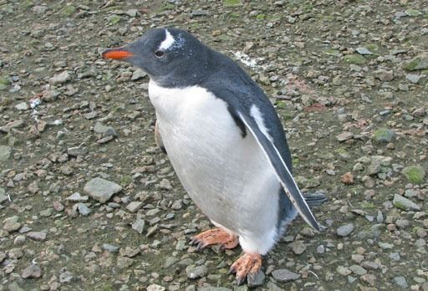
Adelie  http://eol.org/pages/1049602/overview | Chinstrap  http://eol.org/data_objects/31959318 | Gentoo  http://eol.org/pages/1049603/overview

Explore the Encyclopedia of Life (eol.org). What can you find out about the penguin species that live on the Western Antartic Penisula?

__________________________________________________________________________________________________________________________________________________________________________________________________
__________________________________________________________________________________________________________________________________________________________________________________________________

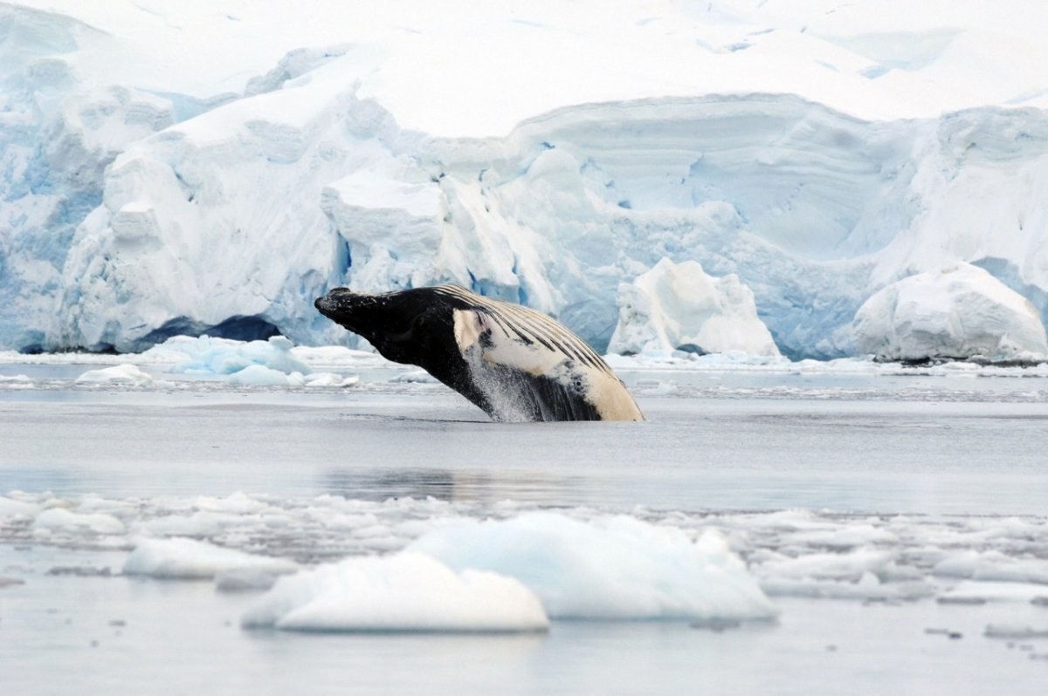 | 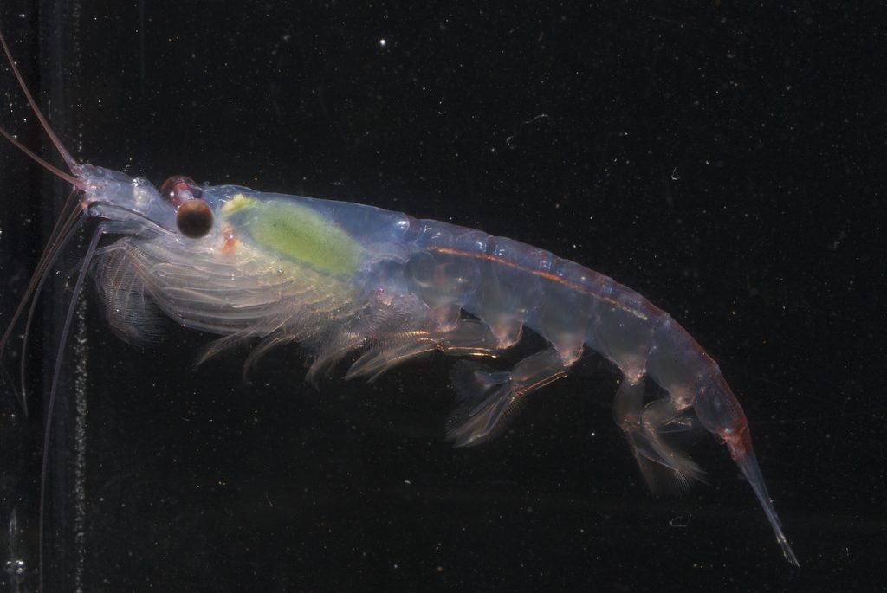 | 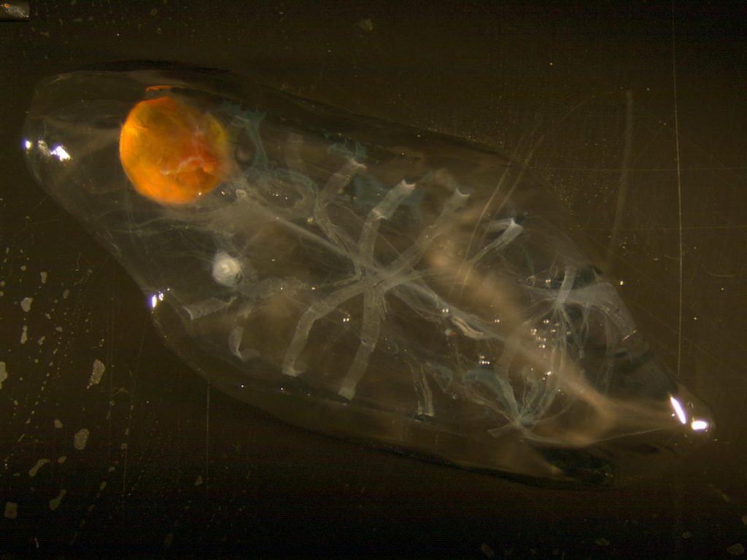
Humpback Whale  http://eol.org/pages/328575/overview | Krill  http://eol.org/pages/509426/overview | Salp  http://www.divediscover.whoi.edu/expedition10/hottopics/salps.html

Explore the Encyclopedia of Life (eol.org) website. What can you find out about the whale species that live on the Western Antartic Penisula?

__________________________________________________________________________________________________________________________________________________________________________________________________
__________________________________________________________________________________________________________________________________________________________________________________________________

V. Data to Explore to Prepare for your Video Teleconference with Palmer Scientists.

Note to teachers: You may want to laminate these graphics and have students use dry erase markers to circle things they do not understand.

Below is a map of the islands around the Penisula where LTER scientists conduct their research:

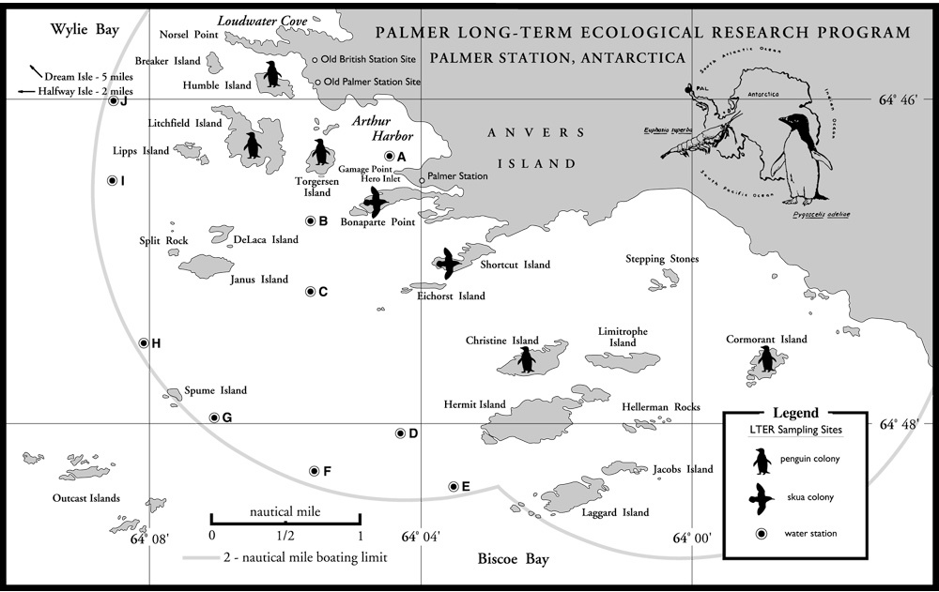

These graphs below tells a story of how the ecosystem is changing in Antarctica:

Adelie, Gentoo, and Chinstrap populations on the Western Antarctic Peninsula (1975-2016).
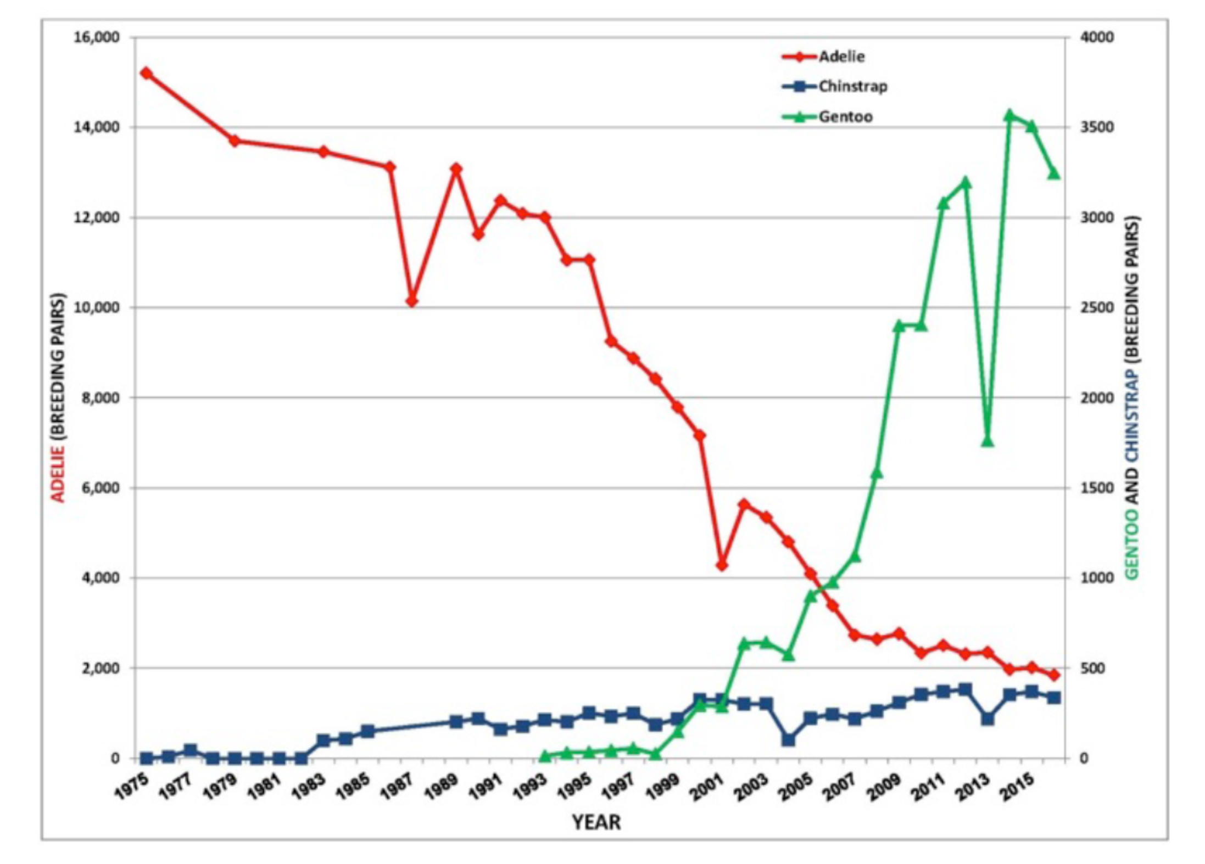

This graph shows the number of days there is ice cover near three islands on the Western Antarctic Peninsula where the penguins live (1980-2016).
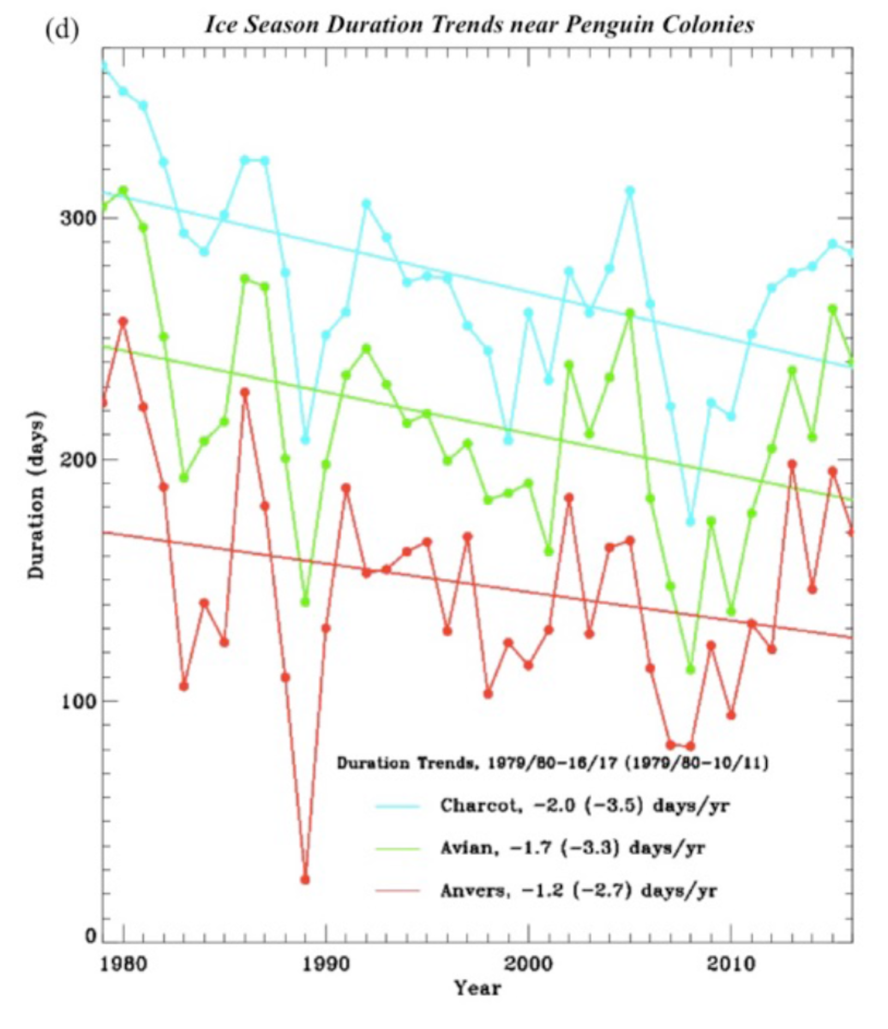

This graph shows the home range of Adelie and Gentoo penguins, and humpback whales around Palmer Station. The data was collected using suction cup tags that satellite track the animals over a few days. The graph to the right was created by scientists measuring how deep the animals dive to forage for their food (krill, small fish).

