Introducing a new way to teach about climate change from local to continental scale: PhenoCams!
Learn how to use real time and long-term scientific data generated by web-cameras called Phenocams, installed in diverse ecosystems throughout North America (forests, deserts, cities, mountaintops, coastlines, and prairies), to make sense of how climate change is impacting your local region as well as the rest of the continent.
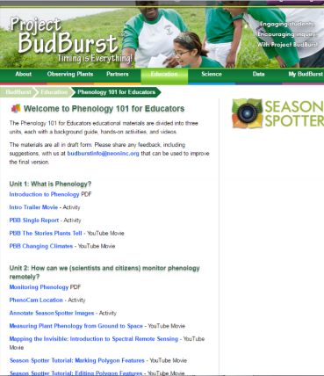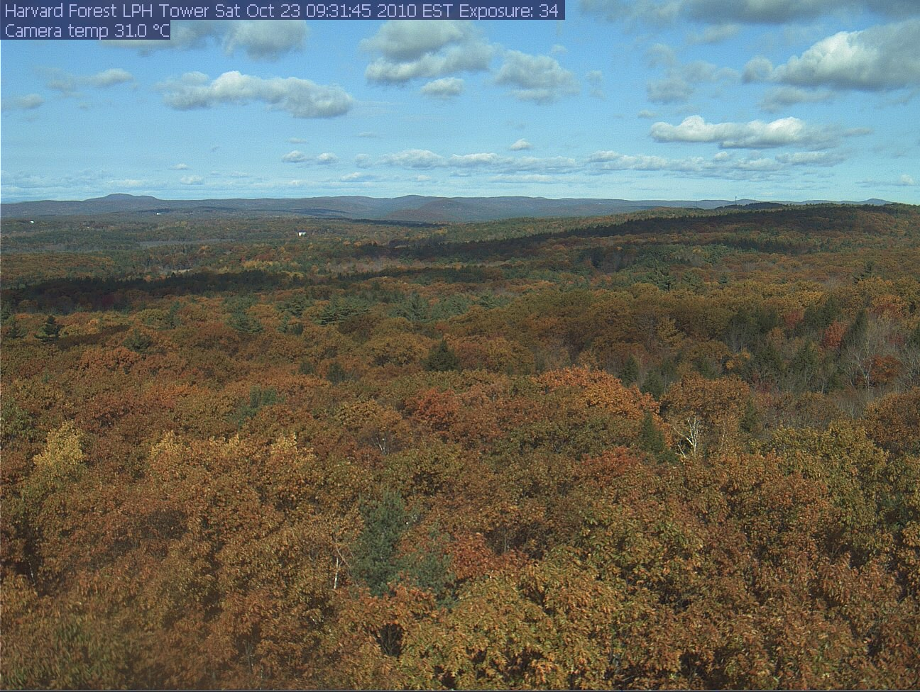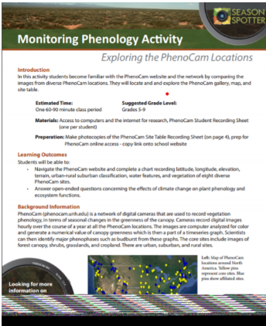
What: PhenoCam Teacher Workshop
When: Thursday, October 15th, from 3:00-5:00 p.m. (Eastern Daylight time)
Where: Online via Zoom- Register Here: https://www.surveymonkey.com/r/PhenoCamRegistration
Cost: Free
Who:
- Scientists:
- Northern Arizona University Regents’ Professor, Andrew Richardson
- Northern Arizona University Assistant Research Professor, Christina Schädel
- Education Hosts:
  - Harvard Forest Schoolyard Ecology Mentor Teacher and Project Coach, Kate Bennett
  - Harvard Forest LTER Schoolyard Ecology Coordinator, Pamela Snow
- Participants:
- STEM Teachers of grades 4 through 12
- Long Term Ecological Research (LTER) Network Educators and their associates
Why: PhenoCam researchers and educators will conduct this online training session to ensure that teachers (1) understand the objectives of ongoing PhenoCam research and the role that PhenoCam data play in quantifying the impacts of global change on terrestrial ecosystems; (2) are able to navigate the PhenoCam project web page to meet their own objectives, including browsing the image archive, interpreting derived data products, and downloading imagery and data; (3) can engage students in grades 4-12 in working with real, up-to-date scientific data related to climate change; (4) find support and tools needed to build students’ understanding of complex ecological processes, using hands-on computer-based learning activities that have been piloted by an experienced classroom teacher.
Phenocam Workshop Agenda
3:00 p.m. An Overview of the Science Behind Phenocams (Andrew)
- What is phenology?
- History of phenological research (Asia, Thoreau, Leopold)
- Why phenology matters in the context of global change
- PhenoCam – background, method, data
- “Through the year” at Harvard Forest
- What is “greenness” (GCC)? How does it relate to things I can see?
- What are transition dates? How do they relate to the timing of spring and autumn? (Bring in imagery from upward-looking camera at HF, and ground observations)
3:20pm: Navigating the PhenoCam Web Page (Christina)
- How to navigate (gallery, maps; searching both)
- How to browse imagery from a site (drill down year / month / day / hour; how to save an individual image)
- How to view “greenness” (Gcc) data – and what it means - walk through some simple comparisons; this gets at some of the “science” nicely I think -
- compare northern vs. southern deciduous forest, difference in growing season length (note “fall dip” in GCC —> peak color)
- compare temperate grassland (Lethbridge, summer active) vs. Mediterranean (Vaira, winter active) vs. tropical (Kamuela, active year round) grassland
- compare New England deciduous (Bartlett) vs evergreen (Howland) forest
- compare co-occurring deciduous and evergreen conifers (Larch, Spruce at SPRUCE)
- How to download imagery (create an account)
- How to download data (link on ROI page)
3:45pm: Scientist Question and Answer, 5-10 min
3:55 p.m. Getting your Students working with Phenocam Science (Kate)
- What Phenocam lessons looked like in Kate’s 5th Grade Classroom
- Online Lesson plans and Educational Resources for Grades 4-12 that you can use
- Try it out now! Kate will lead you in some hands-on exercises that she used with her students so you can have a chance to be the student, and feel out ways you might engage your own students
4:50 p.m. Important educator feedback (online survey) -We highly value your feedback as we are planning to do more Phenocam workshops and want to incorporate teacher input to benefit future participants.
5:00p.m. Formal Workshop Ends. Informal question and Answer may extend as needed

REGISTER HERE: https://www.surveymonkey.com/r/PhenoCamRegistration

