Exploring Palmer LTER
https://pallter.marine.rutgers.edu

I. Antarctica is a Continent: Look on a globe or at the map below. Name three things you notice and two things you wonder about it.

Notice:
- _________________________________________________________________________________________

- _________________________________________________________________________________________

- _________________________________________________________________________________________

Wonder:
- _________________________________________________________________________________________

- _________________________________________________________________________________________

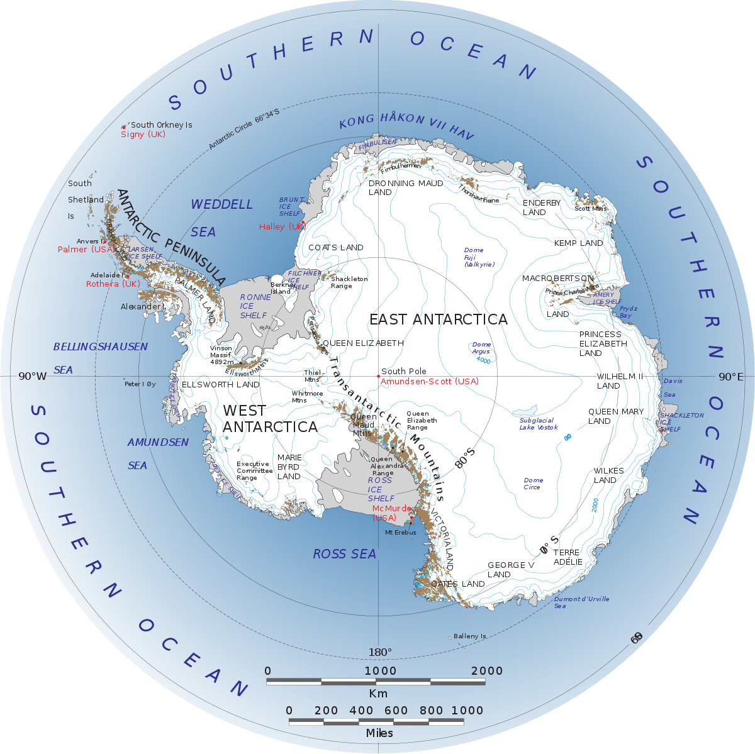
What do you know about the physical characteristics (weather, climate) of the Antarctic ecosystem? Write some of your ideas below:

What organisms live in Antarctica?
Write the name of the organism and one interesting fact about them on this diagram below:
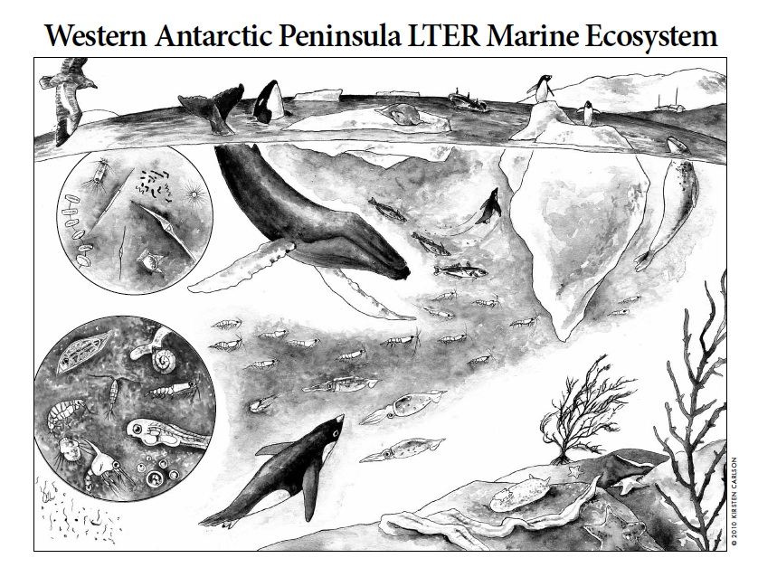

II. LTER Research: Scientists visit Antartica year-round to better understand this important ecosystem.

LTER is an Acronym. Write what each letter stands for below.

L:____________________________________________
T:____________________________________________
E:____________________________________________
R:____________________________________________

What do you think the value is of collecting scientific data over a long period of time in Antarctica?

________________________________________________________________________________________________

Middle and high school students can read about each of the laboratories that work together to understand the Antarctic food web. See https://pallter.marine.rutgers.edu/research-components-labs/

What is most interesting to you? Why? Write some notes below:
_________________________________________________________________________________________________

_________________________________________________________________________________________________

_________________________________________________________________________________________________

III. Research Methods: Antartica is a cold and harsh environment. How do you think scientists study this important ecosystem? What equipment do they use?

_________________________________________________________________________________________________

Take a look at Palmer Station on the webcam:
Station - https://www.usap.gov/videoclipsandmaps/palwebcam.cfm
Torgeson Island (penguins) https://www.usap.gov/videoclipsandmaps/palwebcam.cfm?t=1

What do you notice about Palmer Station?

_________________________________________________________________________________________________

What questions do you have about Palmer Station?

IV. Organisms that Live on the Western Antartic Penisula

Penguins on the Western Antarctic Penisula

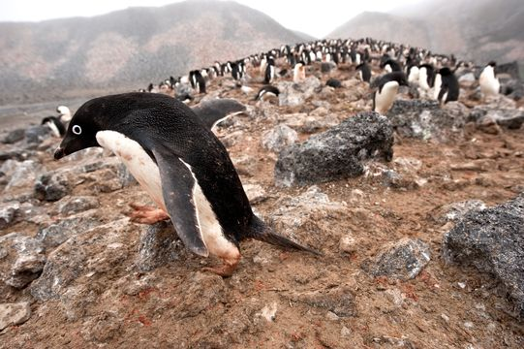 | 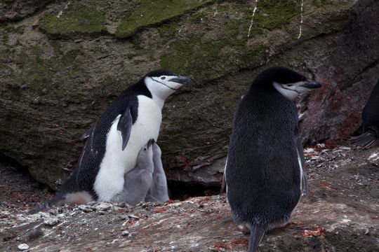 | 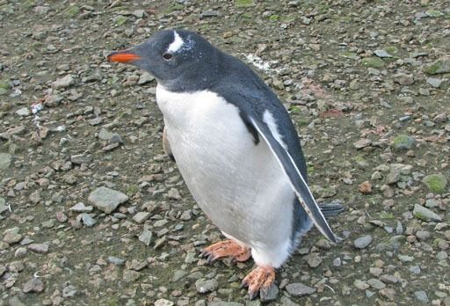
Adelie  http://eol.org/pages/1049602/overview | Chinstrap  http://eol.org/data_objects/31959318 | Gentoo  http://eol.org/pages/1049603/overview

Explore the Encyclopedia of Life (eol.org). What can you find out about the penguin species that live on the Western Antartic Penisula? Write some notes below:

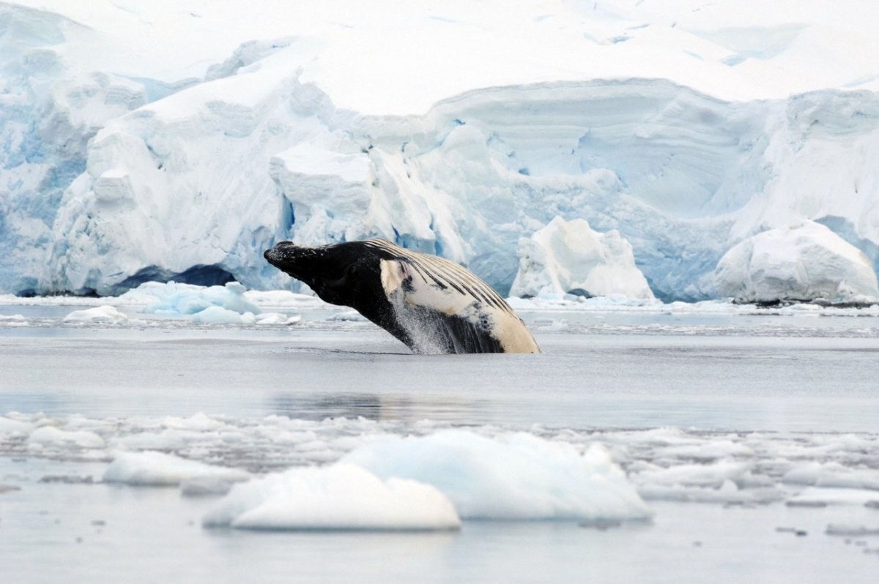 | 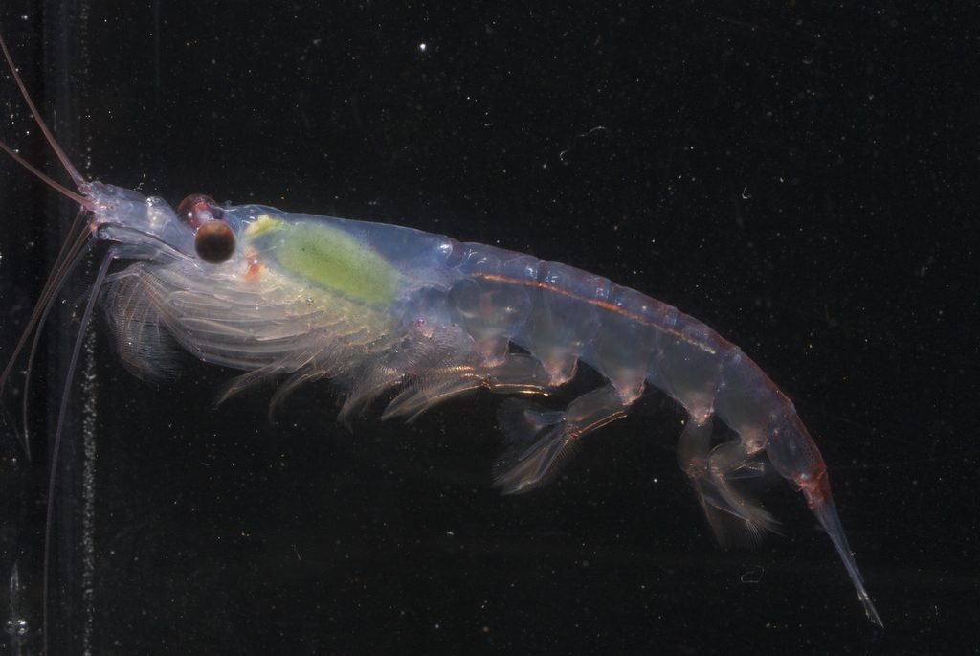 | 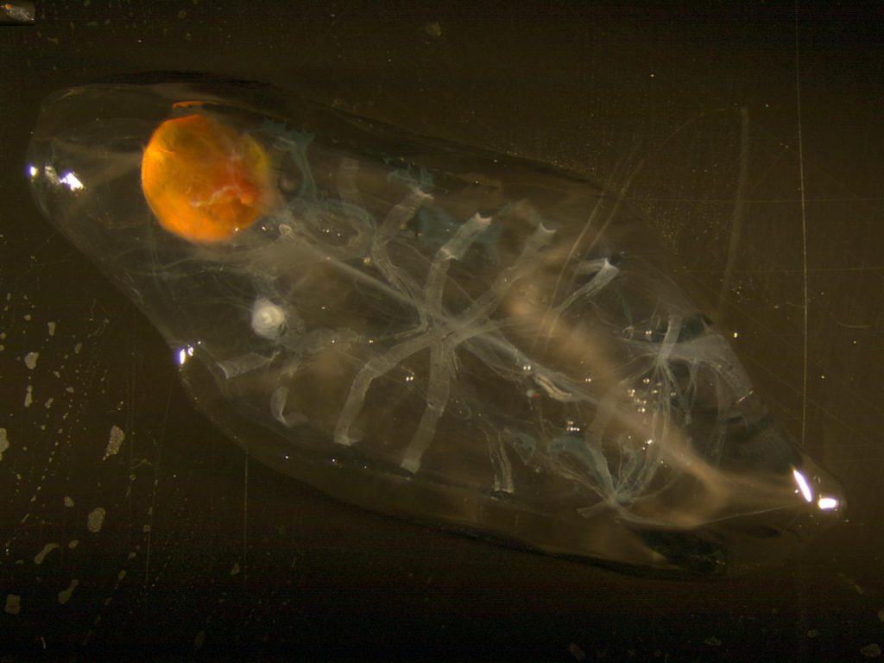
Humpback Whale  http://eol.org/pages/328575/overview | Krill  http://eol.org/pages/509426/overview | Salp  http://www.divediscover.whoi.edu/expedition10/hottopics/salps.html

Explore the Encyclopedia of Life (eol.org) website. What can you find out about the whale species that live on the Western Antartic Penisula?

V. Prepare for your Video Teleconference with Palmer Scientists.

Below is a map of the islands around the Penisula where LTER scientists conduct their research:

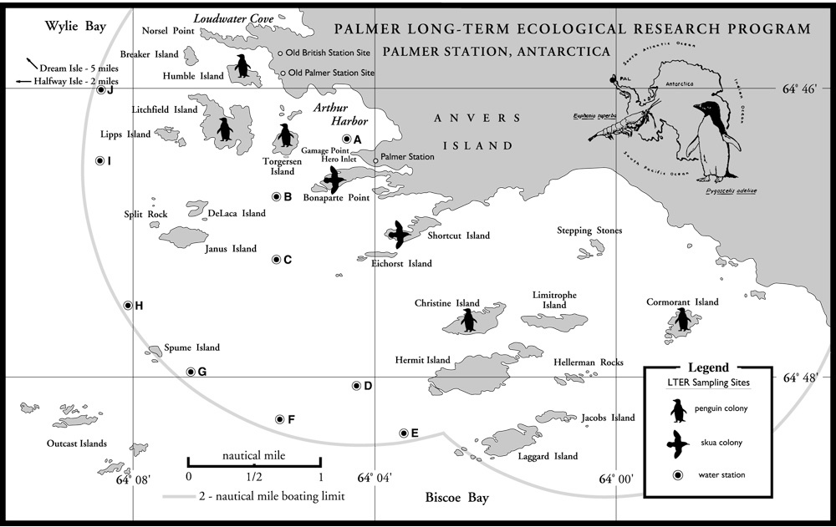

Brainstorm your questions for the scientists here:

