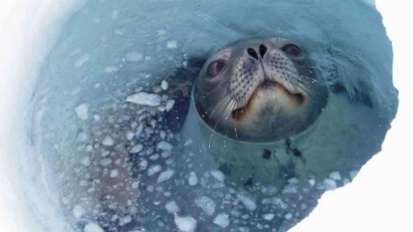
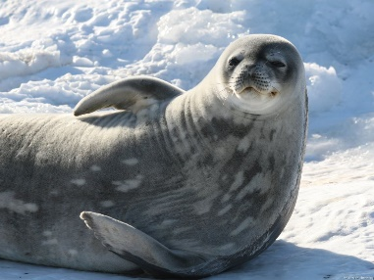
Weddell seals
Scientific name: Leptonychotes weddellii
Size: 9-12 feet long, 900 pounds, small head compared to body
Color: White belly, gray and black back
Diet: fish, squid, octopus and shrimp. They are very good divers, remaining under water for up to 45 minutes and diving very deep.
Special adaptations: Because Weddell seals breath air and live under the fast-ice they must breath through cracks and holes in the ice cover. There are many cracks in the ice during the warmer summer months. During winter these openings freeze over and Weddell seals use their teeth to open the new ice and so maintain holes through which to breathe. Since the seal must find its way to the breathing holes before it runs out of oxygen. Their powers of navigation are highly accurate as they must find these holes even during the darkness of winter.
Source: http://www.antarctica.gov.au/ Photos; Glenn Browning

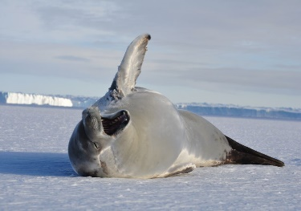
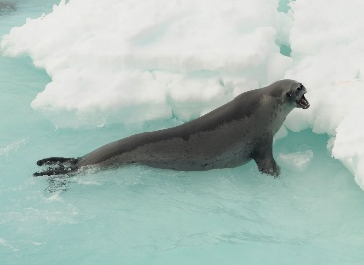
Crabeater seals
Scientific name: Lobodon carcinophagus
Size: 7 feet long, 800 pounds,
slender bodies and long snouts
Color:. Their fur ranges from dark brown to blonde, becoming lighter in summer.
Diet: Despite their name, these seals don’t eat crabs, they eat krill. Their name originates from the German word, Krebs, which covers other crustaceans (such as krill and shrimp) as well as crabs.
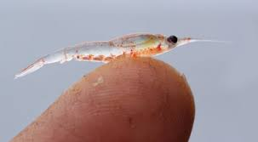
Special adaptations: Crabeater seals spend their entire lives in the pack-ice zone surrounding Antarctica, resting and breeding on the pack-ice, and feeding in the surrounding water. Crabeater seals have specially adapted teeth with extra projections, so that when they gulp in seawater they can strain out the krill.
Krill
Source: http://www.antarctica.gov.au/ Photos; Sarah Robinson, Kate Kloza

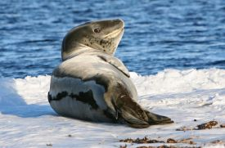
Leopard seals
Scientific name: Hydrurga leptonyx
Size: 9-11 feet long, 700 pounds
Color: White belly, gray and black back
Diet: Leopard seals eat almost anything, including penguins, fish, squid, crustaceans and other seals. Seals eaten include seal pups of Crabeater, Weddell and fur seals.
Special adaptations: Designed for speed, the body is slender and the front flippers are long. The head is large and the jaws open widely revealing exceptionally long and pointy teeth. Like the Crabeater seals, leopard seals have unusual teeth for straining krill from the water. Leopard seals are solitary animals that live in the Antarctic pack ice
Source: http://www.antarctica.gov.au/ Photos; Narelle Campbell

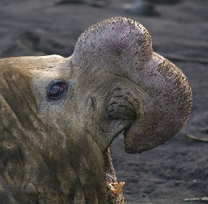
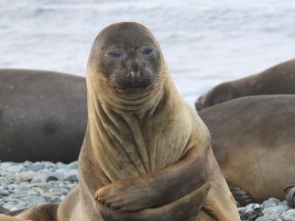

Elephant seals
Scientific name: Mirounga leonina
Size: 9-11 feet long, males can weigh over 5000 pounds
Color: White belly, gray and black back
Diet: Elephant seals migrate south to Antarctica, after breeding, to feed on squid and fish at the edge of the sea-ice.
Special adaptations: Southern elephant seals are named after the large proboscis (nose) of the adult males, which is used to make loud roaring sounds, especially during the mating season. They are big and cumbersome on land, but are superb swimmers and divers. Elephant seals have also adapted to store extra blood in their bodies so that when they go on long deep dives they will have plenty of oxygen.
Source: http://www.antarctica.gov.au/ Photos; Jeremy Smith,Troy Metcalfe)

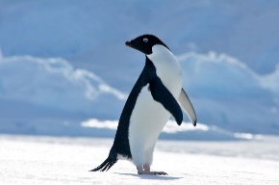
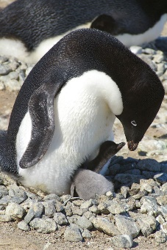
Adélie penguins
Scientific name: Pygoscelis adeliae
Size: A medium sized penguin weighing 8- 12 pounds and standing
27 inches tall
Color: White belly, black back, black head and white eye ring. Reddish beak with a black tip
Diet: Mostly fish, squid and krill
Special adaptations: Adélies are excellent swimmers. Adélies are not just good at swimming. They are very determined and successful long distance walkers, even though their short legs restrict them to a waddle on land.
Adélie penguins build nests out of the pebbles they find on dry land during spring. They choose a sloping site so that when snow melts, the water runs away from the nest. The nest must also be close to open water so the Adélies can eat.
Source: http://www.antarctica.gov.au/ Photos; Kate Kloza, Matthew Low)

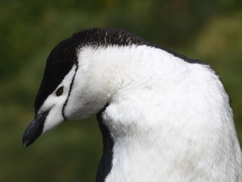
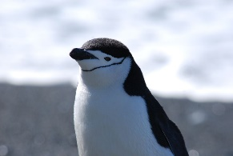

Chinstrap penguins
Scientific name: Pygoscelis antarctica
Size: grow to 2-2 1/2 feet tall and weigh around 10 pounds.
Color: The top of a chinstrap's head is black and the face is white, with a stripe of black extending under the chin. They are named for this narrow black band under their heads.
Diet: Feed mainly on krill and fish and are considered near-shore feeders, feeding close to their breeding colonies.
Special adaptations: Chinstrap penguins on land often toboggan – laying on their stomachs, propelling themselves by their feet, and using their flippers. They climb using all four limbs and are able to jump large distances to reach footholds
Source: http://www.antarctica.gov.au/ Photos; Michele Smith, Steve Barton)

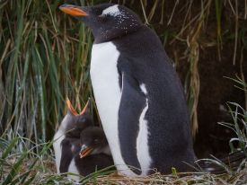
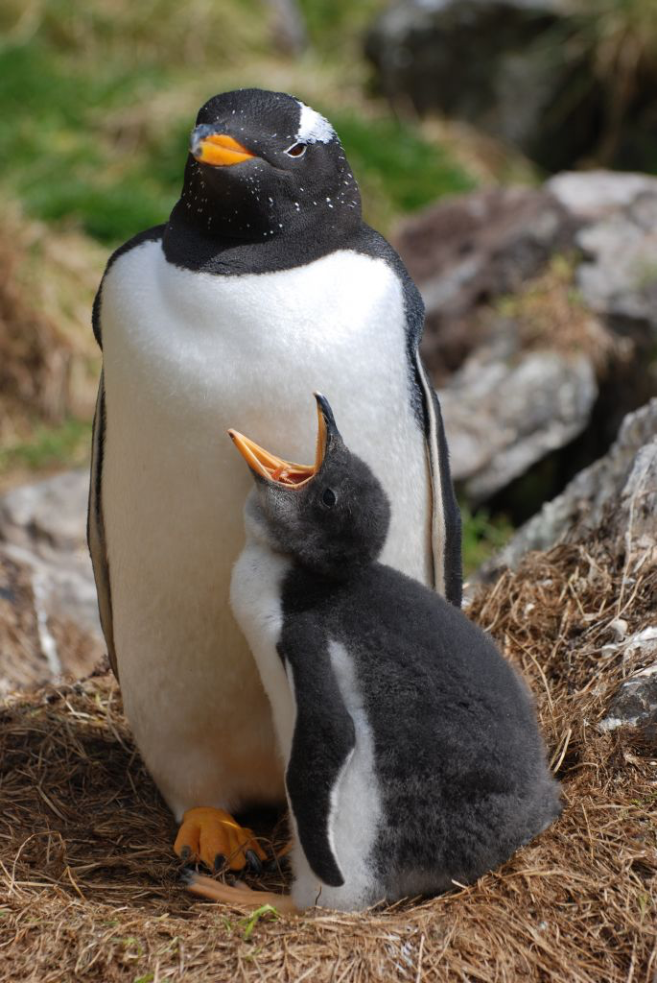
Gentoo penguins
Scientific name: Pygoscelis papua
Size: stand about 2 1/2 feet tall.
Color: A bright red-orange bill and a white-eye patch above each eye makes it easy to identify these penguins.
Diet: Gentoo penguins feed on rock cod, amphipods and cephalopods (mainly squid). Females tend to eat more krill than the males, while the males tend to eat more fish than the females.
Special adaptations: Gentoo penguins look for food at sea close to the colony, as a result, their chicks are fed frequently. This may explain why Gentoo penguins rear two chicks each year more often than other penguin species. Breeding success is affected by food availability.
Source: http://www.antarctica.gov.au/ Photos; Greg Stone, Steve Bone)

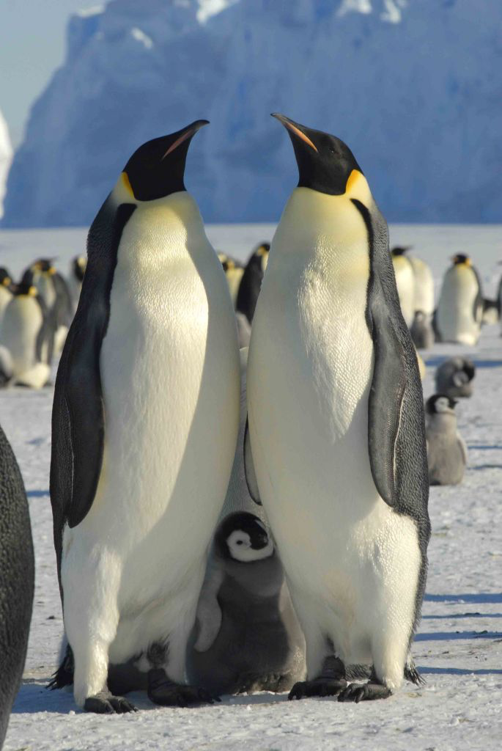
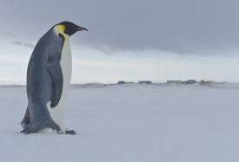
Emperor penguins
Scientific name: Aptenodytes forsteri
Size: The emperor is the largest penguin species.
They grow about 4 feet tall and can weigh about 85 pounds.
Color: black head, chin, and throat, with broad yellow patches on each side of the head.
Diet: They are excellent divers and can dive very deep to catch mostly fish, squid and krill.
Special adaptations: Emperor penguins are truly amazing birds. They not only survive the Antarctic winter, but they are capable of breeding during the worst weather conditions on earth. The emperor with excellent insulation in the form of several layers of scale-like feathers. They have a very small bill and flippers, which conserve heat. They are also very social creatures, and one of their survival mechanisms is an urge to huddle together to keep warm. They even take turns being on the edges, or coldest spots, of the huddle. This huddling instinct means that they do not defend any territory. The emperor penguin is the only species of penguin that is not territorial.
Source: http://www.antarctica.gov.au/ Photos; Stu Shaw, Gary Miller)

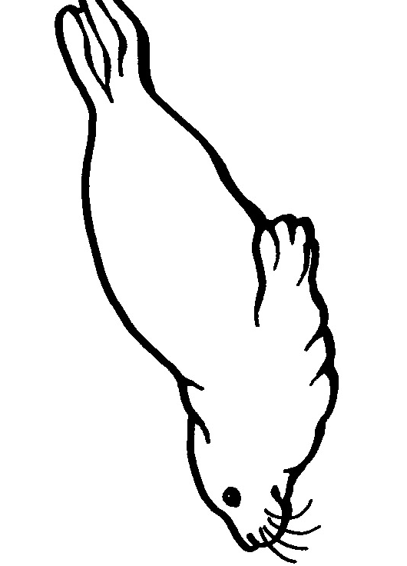
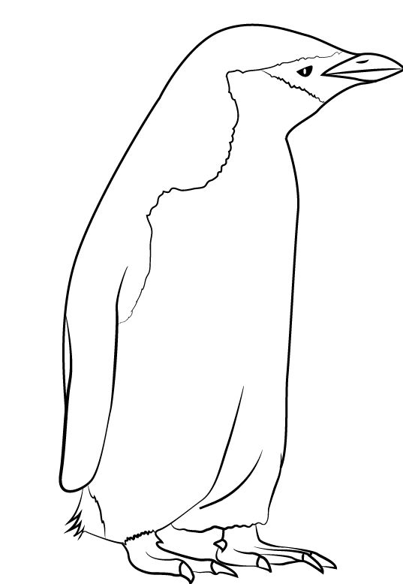

A Field Guide to
Seals and Penguins of Antarctica

